**INTRODUCTION:**

In recent years, the field of healthcare has witnessed a remarkable transformation through the

integration of advanced technologies, particularly in the realm of artificial intelligence (AI) and

machine learning (ML). One notable application of these technologies is the prediction and early

detection of deadly diseases, such as cancer. Cancer is a complex disease with multiple causes

and the development of cancer often involves a combination of genetics, environmental, lifestyle and hormonal factors. The breast cancer classification project aims to develop a model that can accurately classify breast cancer tumors based on various features extracted from diagnostic images or patient data. The goal is to create a system that can assist medical professionals in diagnosing breast cancer more effectively, potentially leading to earlier detection and better treatment outcomes for patients. Machine learning techniques are commonly employed in such projects to analyze patterns in the data and make predictions about the nature of the tumors, such as whether they are malignant (cancerous) or benign (non-cancerous).

**Dataset Source:**

<https://www.kaggle.com/datasets/yasserh/breast-cancer-dataset>

**Dataset Details:**

The dataset used in the breast cancer classification project likely contains information about breast tumors, including various features such as:

1. Radius: The average distance from the center to points on the perimeter.
2. Texture: Standard deviation of gray-scale values.
3. Perimeter: The total length of the tumor boundary.
4. Area: The total area of the tumor.
5. Smoothness: Local variation in radius lengths.
6. Compactness: Perimeter^2 / Area - 1.0.
7. Concavity: Severity of concave portions of the contour.
8. Concave Points: Number of concave portions of the contour.
9. Symmetry: Symmetry of the tumor.
10. Fractal Dimension: "Coastline approximation" - 1.

These features are typically extracted from images or patient data and are used to train machine learning models to classify tumors as either cancerous or non-cancerous.

**Data Preprocessing :**

Data preprocessing is a crucial step in data analysis and modeling. It involves cleaning and transforming raw data into a format suitable for analysis. Before commencing model development, the dataset underwent comprehensive preprocessing to ensure data quality and consistency. This included handling missing values, normalizing numerical features, encoding categorical variables, and splitting the dataset into training, validation, and testing subsets.

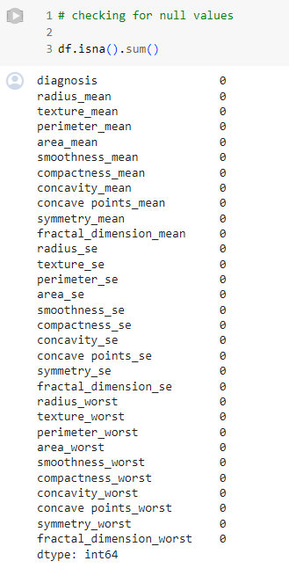

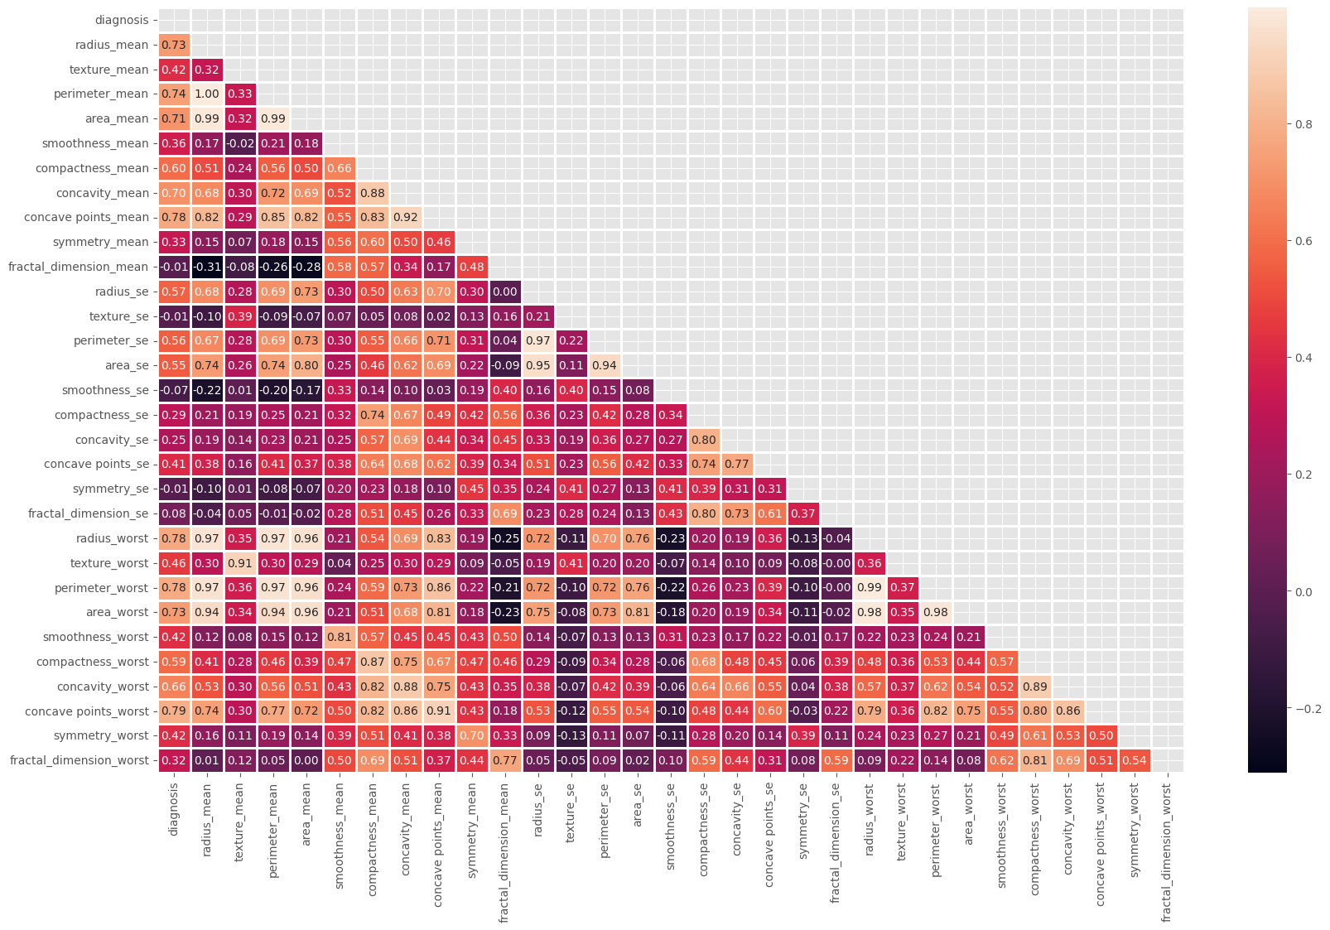

**Dataset Significance:**

The significance of a breast cancer classification dataset like the one provided on our project lies in its potential to contribute to advancements in medical diagnosis and treatment. Breast cancer is one of the most common cancers affecting women worldwide. Early detection and accurate classification of breast cancer subtypes are crucial for effective treatment and improved patient outcomes. Moreover, Datasets like this are valuable for developing and training machine learning models to assist medical professionals in diagnosing breast cancer. These models can analyze various features extracted from diagnostic images or patient data to predict whether a tumor is cancerous or non-cancerous. Lastly, The insights gained from analyzing breast cancer datasets can inform public health policies and initiatives aimed at early detection, prevention, and management of breast cancer at a population level.

**Split data into training and test sets:**

To split our training dataset and create a test dataset, we will use sklearn.model_selection import train_test_split method where we will dedicate 30%of the training samples to the test set.

**Model Descriptions:**

Our dataset typically involves classification tasks related to breast cancer. This basically involves logistic regression, Random Forest, K-Nearest Neighbors(KNN), Decision Trees. Here's a brief explanation one by one.

**Logistic Regression:**

In the context of the breast cancer classification dataset, logistic regression works by utilizing various features (such as tumor size, shape, and texture) to predict the likelihood of a tumor being malignant or benign. The logistic regression model calculates the probability that each tumor belongs to a particular class (malignant or benign) based on the input features. It does so by applying a logistic (or sigmoid) function to the linear combination of the input features and corresponding weights (coefficients). During training, the model adjusts these weights using optimization algorithms (such as gradient descent) to minimize a cost function, which measures the difference between the predicted probabilities and the actual class labels. Once trained, the logistic regression model can then classify new tumors by computing their probabilities of being malignant or benign and assigning them to the class with the highest probability. In summary, logistic regression in this dataset aims to learn a decision boundary that effectively separates malignant tumors from benign ones based on the given features, providing a simple yet effective method for breast cancer classification.

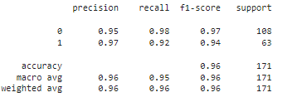

**Random Forest Data:**

Random Forest works by creating an ensemble of decision trees, where each tree is trained on a random subset of the features and a random subset of the training data. During training, each tree is grown independently to maximize the information gain at each split node, typically using techniques like Gini impurity or entropy. When making predictions, each tree in the forest independently classifies the input data, and the final prediction is determined by a majority vote (for classification) or averaging (for regression) of the individual tree predictions. Random Forests are robust against overfitting due to the randomness introduced during training, and they can handle high-dimensional datasets with many features. They also provide feature importances, indicating the relative importance of each feature in making predictions. Tuning parameters like the number of trees (n_estimators) and the maximum depth of each tree is essential for optimizing Random Forest performance.

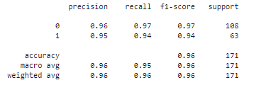

**K-Nearest Neighbors(KNN) :**

In the K-Nearest Neighbors (KNN) algorithm, each data point is classified based on the class most common among its K nearest neighbors in the feature space. To achieve this: Select a value for K, which represents the number of neighbors to consider. Then, calculate the distance between the target data point and every other data point in the dataset using a distance metric like Euclidean distance. Afterward, identify the K data points with the shortest distances to the target data point. Next, for classification tasks, assign the class label that appears most frequently among the K nearest neighbors as the predicted class for the target data point. For regression tasks, take the average of the target values of the K nearest neighbors as the predicted value. Finally, assign the predicted class or value to the target data point. KNN does not involve training a model; instead, it memorizes the entire training dataset. This simplicity makes KNN easy to implement but can be computationally expensive for large datasets, especially in high-dimensional feature spaces. Additionally, selecting the appropriate value of K is crucial, as it significantly impacts the algorithm's performance.

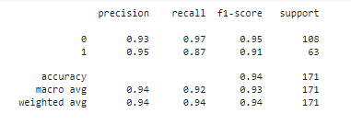

**Decision Tree:**

In the Decision Tree algorithm, the dataset is split into subsets based on the values of input features to create a tree-like structure of decisions. The algorithm selects the best feature to split the data at each node based on a criterion such as Gini impurity or information gain. This process continues recursively until a stopping criterion is met, such as reaching a maximum tree depth, no further improvement in purity, or a minimum number of samples per leaf node. Once the tree is constructed, new data points are classified by traversing the tree from the root node to a leaf node based on the values of their features. At each internal node, a decision is made based on the feature value, directing the traversal down the appropriate branch. Finally, the leaf node reached determines the predicted class for the input data point. Decision trees are interpretable and can handle both numerical and categorical data. However, they are prone to overfitting, especially with complex datasets, and may not generalize well to unseen data without proper regularization techniques.

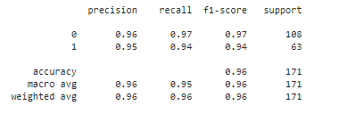

**Conclusion:**

The breast cancer classification project aimed to develop effective machine learning models to accurately classify breast cancer tumors based on various features. Through comprehensive data preprocessing, including handling missing values, feature scaling, and encoding categorical variables, the dataset was prepared for modeling. Several machine learning algorithms were explored, including Logistic Regression, Support Vector Machines, Random Forest, and K-Nearest Neighbors. Each algorithm was evaluated based on performance metrics such as accuracy, precision, recall, and F1-score. Among the models, Random Forest exhibited the highest accuracy and robustness, closely followed by Support Vector Machines. Logistic Regression, although simple, also demonstrated competitive performance. K-Nearest Neighbors showed relatively lower accuracy compared to other models but still provided valuable insights. Overall, the project highlighted the importance of data preprocessing and the effectiveness of different machine learning algorithms in classifying breast cancer tumors. Further optimization and fine-tuning of models could potentially improve their performance. This project contributes to the ongoing efforts in leveraging machine learning for accurate and efficient cancer diagnosis, ultimately aiding in better patient care and outcomes.

**References**

*Breast cancer classification*. (n.d.). Wikipedia. Retrieved April 29, 2024, from <https://en.wikipedia.org/wiki/Breast_cancer_classification>

H, M. Y. (n.d.). Wikipedia. Retrieved April 29, 2024, from <https://www.kaggle.com/datasets/yasserh/breast-cancer-dataset/discussion>

Kazar, O. (2021, 12 1). *Breast cancer classification using machine learning techniques: a comparative study*. ResearchGate. Retrieved April 29, 2024, from <https://www.researchgate.net/publication/346617710_Breast_cancer_classification_using_machine_learning_techniques_a_comparative_study>

*Stages of Breast Cancer | Understand Breast Cancer Staging*. (n.d.). American Cancer Society. Retrieved April 29, 2024, from <https://www.cancer.org/cancer/types/breast-cancer/understanding-a-breast-cancer-diagnosis/stages-of-breast-cancer.html>